Rajmatie Arjune

February 1st 2015

# Assignment:

# Install Supplemental Software & Server maintenance

Upgrade Python 3 was done through the “sudo apt-get upgrade” command.

The analysis for upgrade with specific information on software properties, items that will be removed, archived and disk space information was followed by option to continue with [y/n] choices.

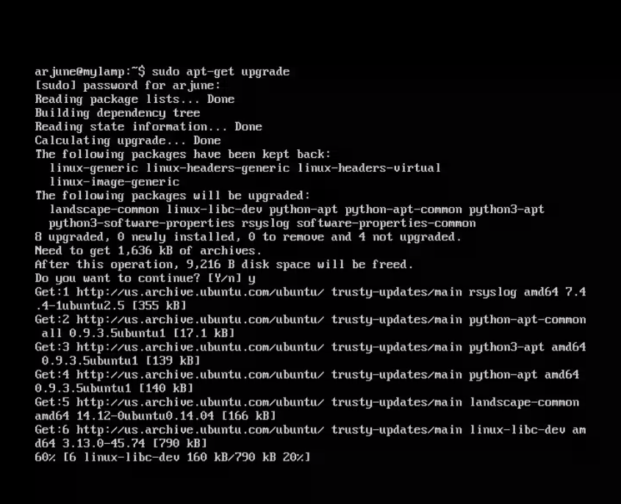

The choice of [y] proceeded to accessing Ubuntu archive, main system log and pertinent software patches for python through Linux system.

Unpacking and preparing the software update through the software resulted in a successful Python upgrade.

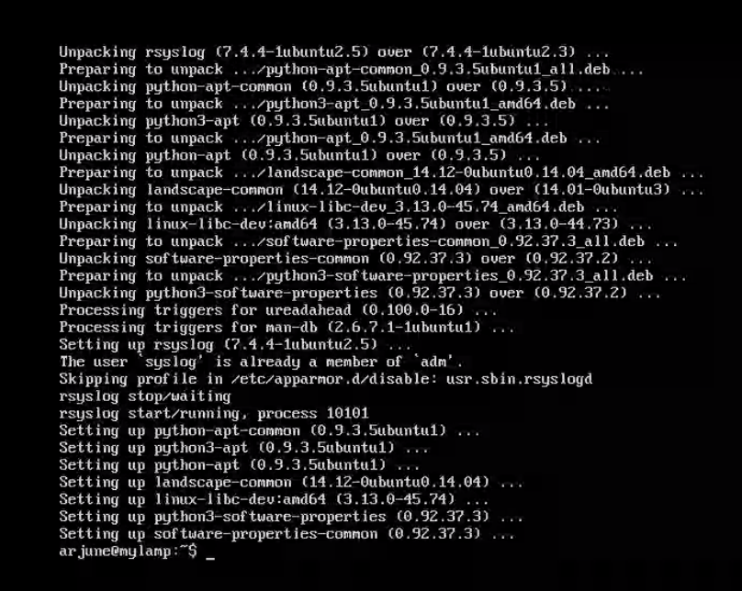

Mysql-client was also installed.

